**Chatbot Integration with Facebook Messenger**

To connect with Facebook first we need to create a few things:

* **Facebook Page**: A Facebook Page will be used as the identity of your Messenger experience. When people chat with your app, they will see the Page name and the Page profile picture. To create a new Page, visit <https://www.facebook.com/pages/create>
* **Facebook Developer Account**: Your developer account is required to create new apps, which are the core of any Facebook integration. You can create a new developer account by going to the [Facebook Developers](https://developers.facebook.com/) website and clicking the 'Get Started' button.

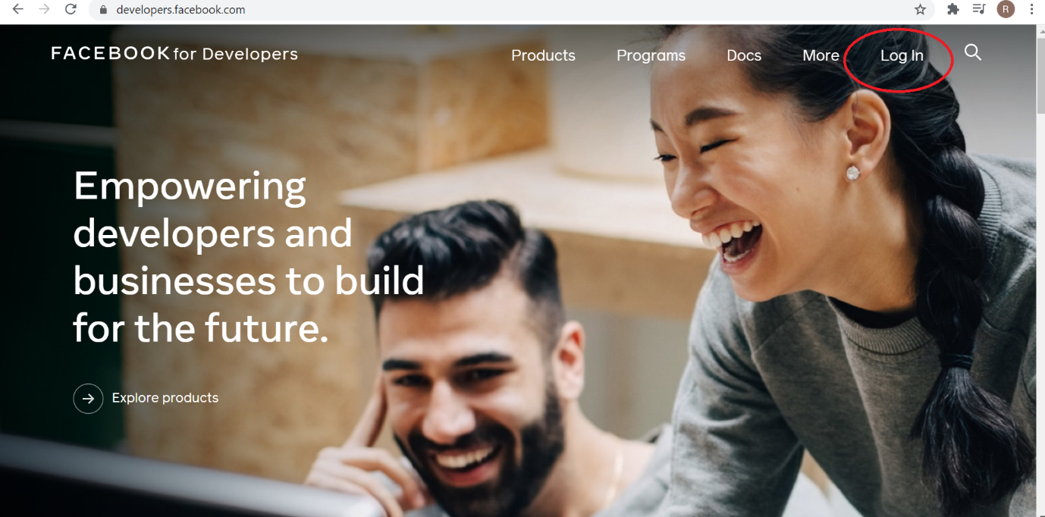

* Once you have your facebook Developers account. Next, click “My Apps” from the pane on the top right of the page.

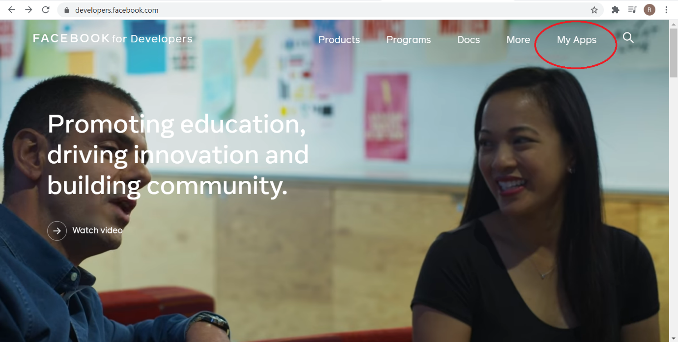

* Choose “Add a new App” a name for your App (ex. Botzer) and provide your email.

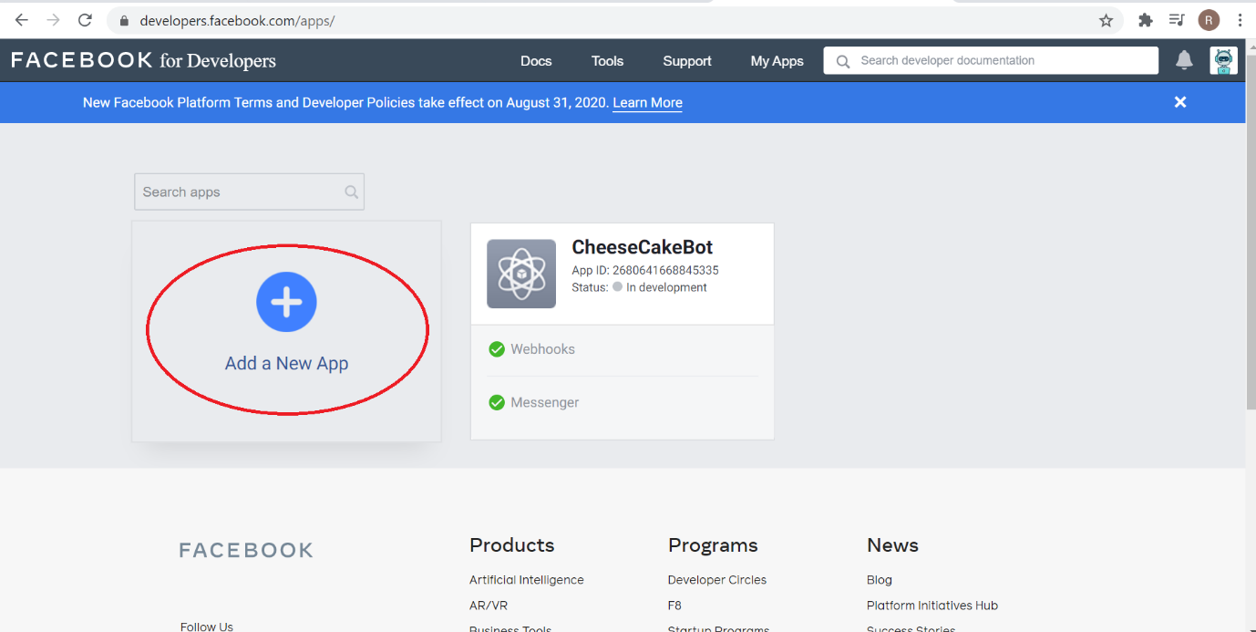

* Fill the App display name and other additional details to create an App.

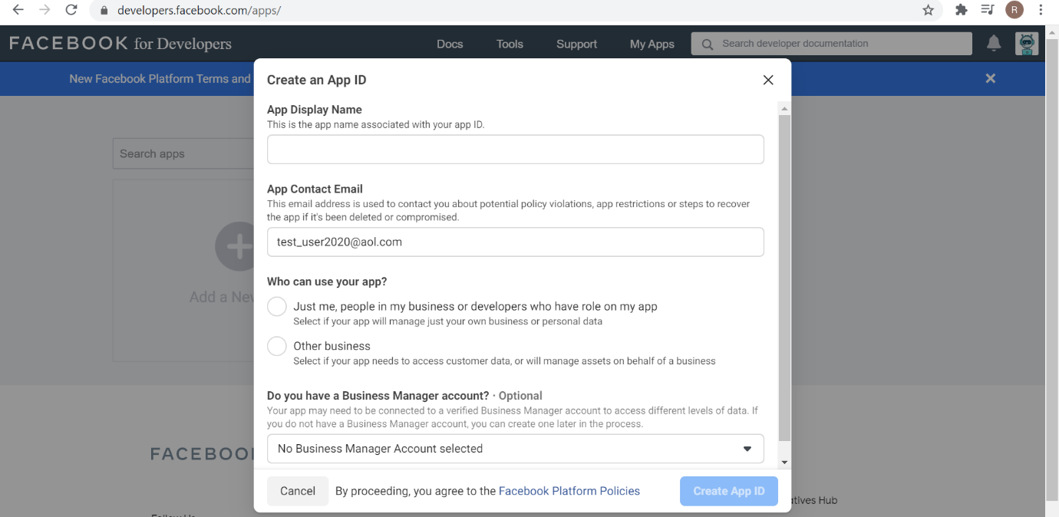

* Next, when prompted on the next page for the type of product you are building, click the “Set Up” button on the Messenger option.

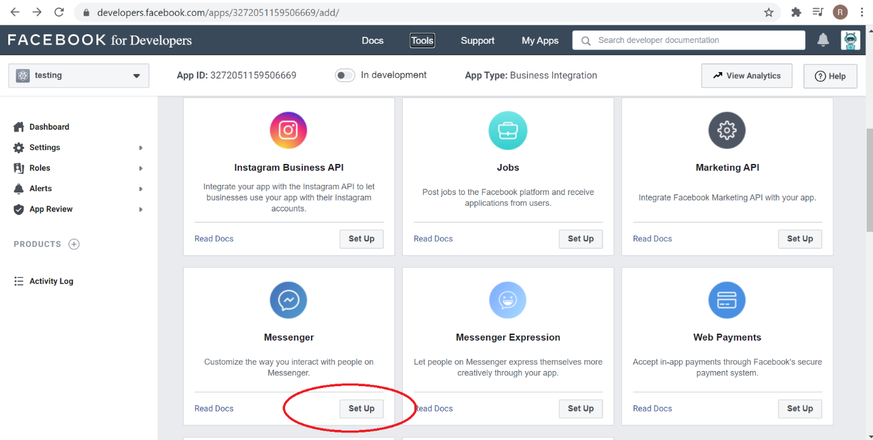

* The Messenger Platform will be added to your app, and the Messenger settings console will be displayed.

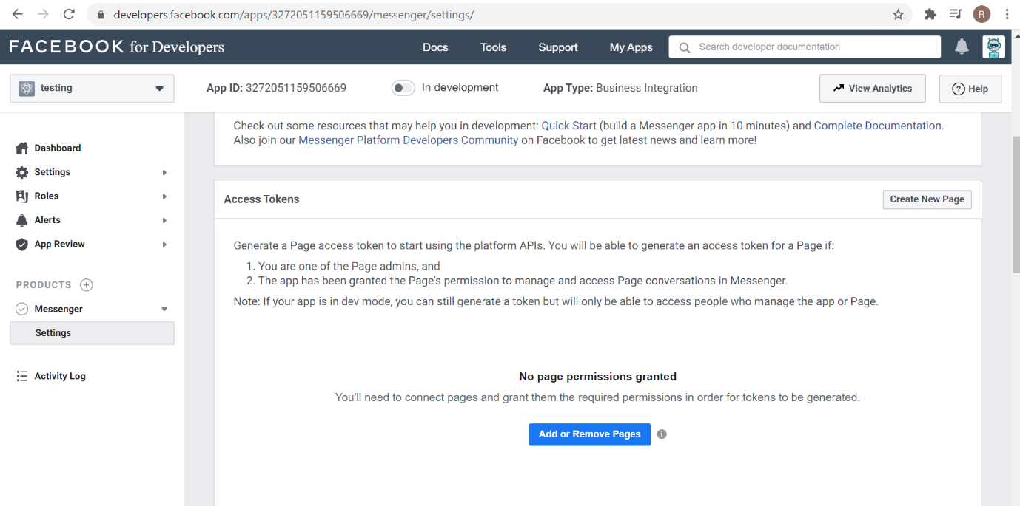

* Subscribe your app to a Facebook Page

Click 'Add or Remove Pages' and select the pages you want to subscribe your app to. Your webhook will receive events for each selected page when people chat with it through Messenger.  
  
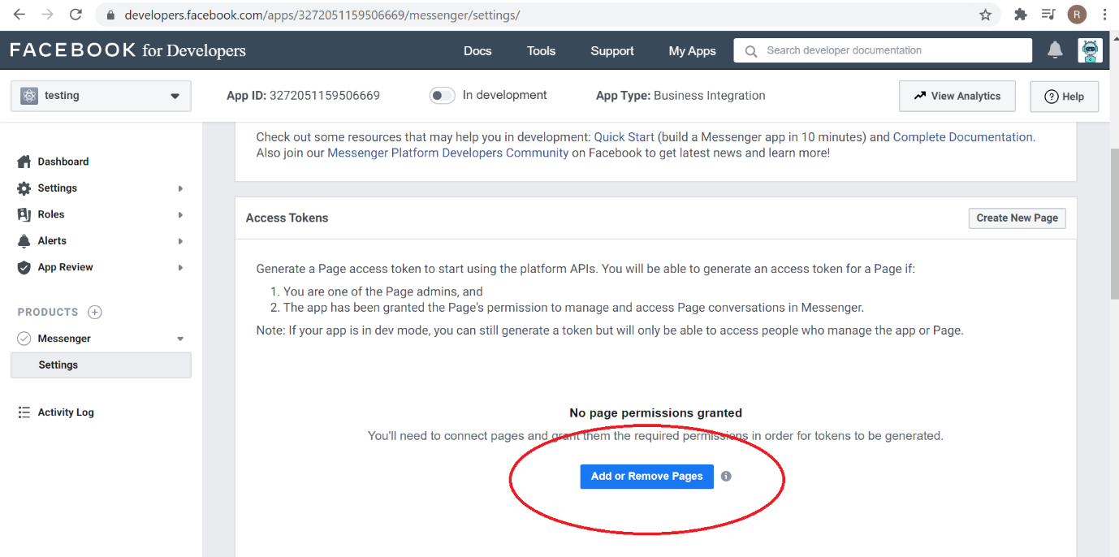

In the 'Access Tokens' section there will be a Generate Token button for each authorized Page. Make sure to save the access token, it's needed as we have to provide this access token for the ACCESS_TOKEN placeholder text in code to send messages using the [Send API](https://developers.facebook.com/docs/messenger-platform/reference/send-api/).

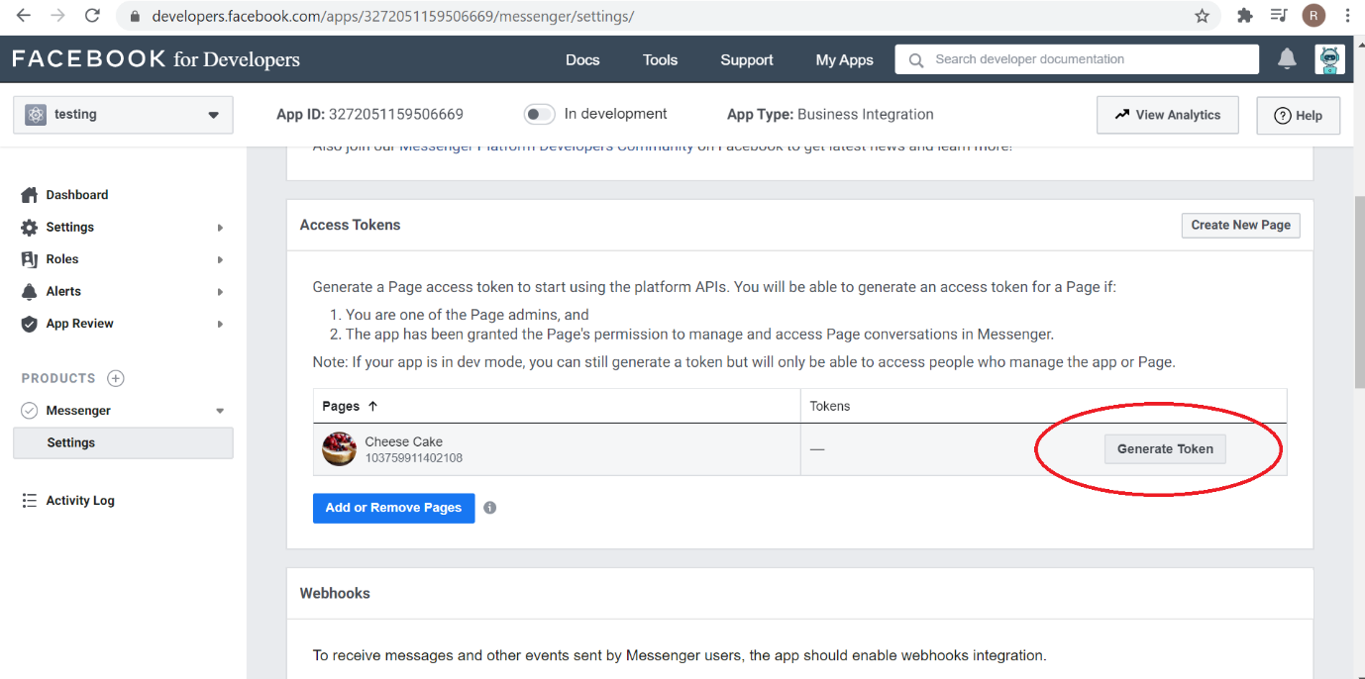

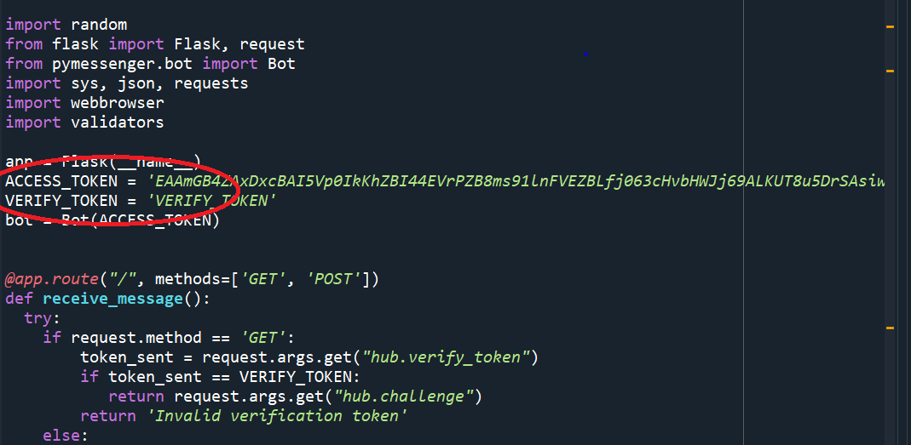

Click the Webhooks tab and click on “Edit Subscription.Here we have to provide the callback URL .To protect your bot, Facebook requires you to have a verify token. When a user messages your bot, Facebook will send your bot the message along with this verify token to check and verify the message is an authentic request sent by Facebook. Choose a string you want to use for your verify token and place the same verify token in the Verify Token field in code.  
  
For the subscription fields, be sure to check the messages, messaging_postbacks, message_deliveries, messaging_pre_checkouts boxes.   
When you’re finished, click “Verify and Save.”

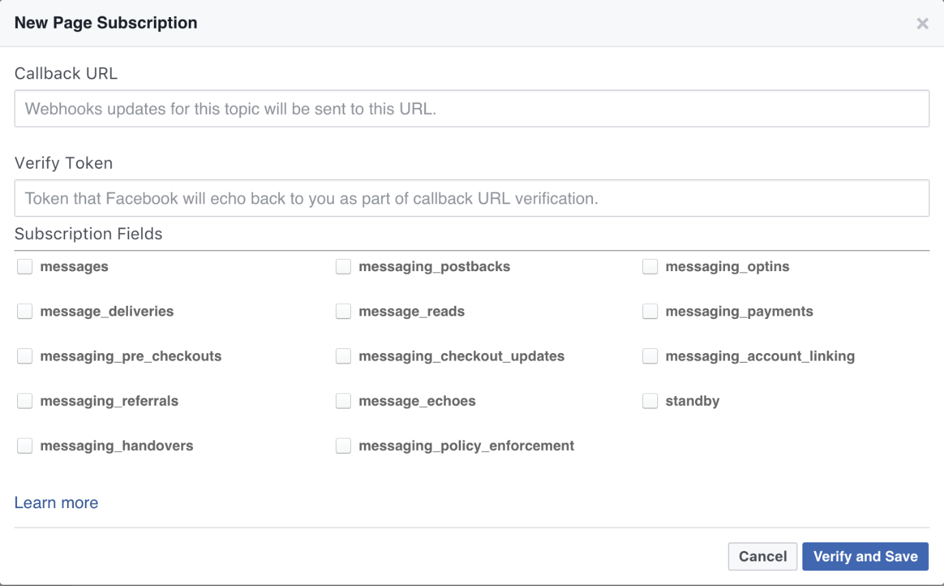

* Once we have configured our page and app. Navigate to the facebook page to test your bot.

